

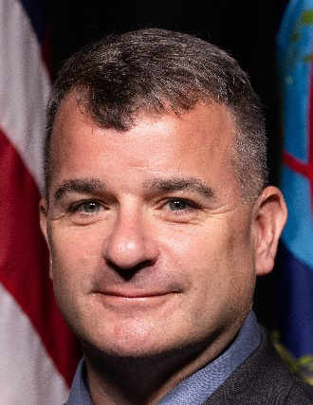

**Donald J. Young**

Chief, Open Source Branch

Advanced Analytics, Artificial Intelligence, and Machine Learning (A³IM) Division

United States Central Command (USCENTCOM) Directorate of Intelligence (J2)

Mr. Donald J. Young assumed the duties of Chief, Open Source Branch, A³IM (CCJ28) in July 2022. In this position, he guides the USCENTCOM Open Source Branch to collect, process, exploit and disseminate Publicly and Commercially Available Information and Data to produce timely open source intelligence, delivering insights, indicators, and warning enabling all-source analysis that mitigates strategic surprise and supports the planning and execution of operations, policy development, and achievement of USCENTCOM objectives.

Mr. Young has held multiple positions in the USCENTCOM J2 including Special Projects Officer and Chief, Cyber Intelligence Branch for the Trans-Regional Issues Office.

Prior to his assignments at USCENTCOM, Mr. Young served over 17 years in multiple assignments at the United States Special Operations Command (USSOCOM). Mr. Young served as a Team Chief, Senior Analyst, Instructor/Trainer and Command Briefer. This included serving in cross-directorate assignments across the Command in the J2, J35, J39, J3X, J54 and J7. Mr. Young was also detailed as a Command Representative and member of the USSOCOM’s Special Operations Support Team in CIA’s Counter-Terrorism Center during the height of the Iraq War.

Mr. Young has served in a variety of positions throughout his intelligence career including deployments to Iraq, Afghanistan, and Jordan. He received a Graduate Degree in Strategic Intelligence from the American Military University and is a Graduate of the Joint Forces College’s Joint Combined Warfare School.

In addition to his service with DIA, Mr. Young is a Chief Warrant Officer Four in the United States Army Reserve with over 33 years of service.